TECHSPERT SYSTEMS

123 Park Place

Newark, New Jersey 07129

1 (800) 228-4812

TO: Cordelia Twomey

FROM: October Hudley

DATE: July 24, 2013

SUBJECT: Discuss **F**inding of United States Population

Enrolled in K-12 Public Education

United States Population Enrolled in K-12 Public Education

Introduction

The graph illustrates the United States population enrollment trends in K-12 public education. (Illustration 1.)

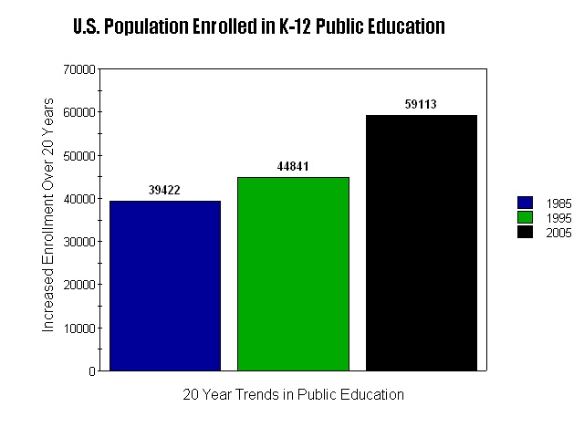

Illustration 1

Discussions

The enrollment population in the public school according to the diagram trendline reflected an increase from 1985 to 2005. The total enrollment population in the public school was 39, 422 in 1985. The total enrollment was 44,841 in 1995 and 59, 113 in 2005. In comparison with the data from 1985 to 1995, there was an approximate and increase in enrollment. This amount increased by 5,000 students within a ten- year span. Overall, it can be clearly seen there was a considerable upward trend in the enrollment of students within years 1995to 2005.

In kindergarten through grade eight, enrollment increased from 27.0 million in 1985 to an estimated 32.3 million in 1995. Enrollment in public elementary and secondary schools increased 22% between 1985 and 2005. The fastest enrollment in elementary grade levels rose 24% over a period from 27.0 million to 33.5 million (National Center for Educational Statistics).

Summary

Although state law varies about when children should be enrolled in school, overall it is required that school begin at the age of six and continue to age of sixteen. Public schools are governed and funded by the state, the local, and federal the government. (National Center for Educational Statistics).

Thank you for reviewing the findings of the student population enrolled in public school from 1995 to 2005. If you have any questions I can be reached at 1 (800) 228-4812 or feel free to email me at [ohudley@techpertsystem.com](mailto:ohudley@techpertsystem.com).

BIBLIOGRAPHY

National Center for Educational Statics. Retrieved July 25, 2013, from

http://nces.ed.gov/programs/digest/d05/

US Census Bureau. (nd.) Retrieved from http://www.census.gov